SOP for users to join
- Click on the link shared by training coordinators.

- Link will take users to the training details page; however first click leads to the registration for the training.

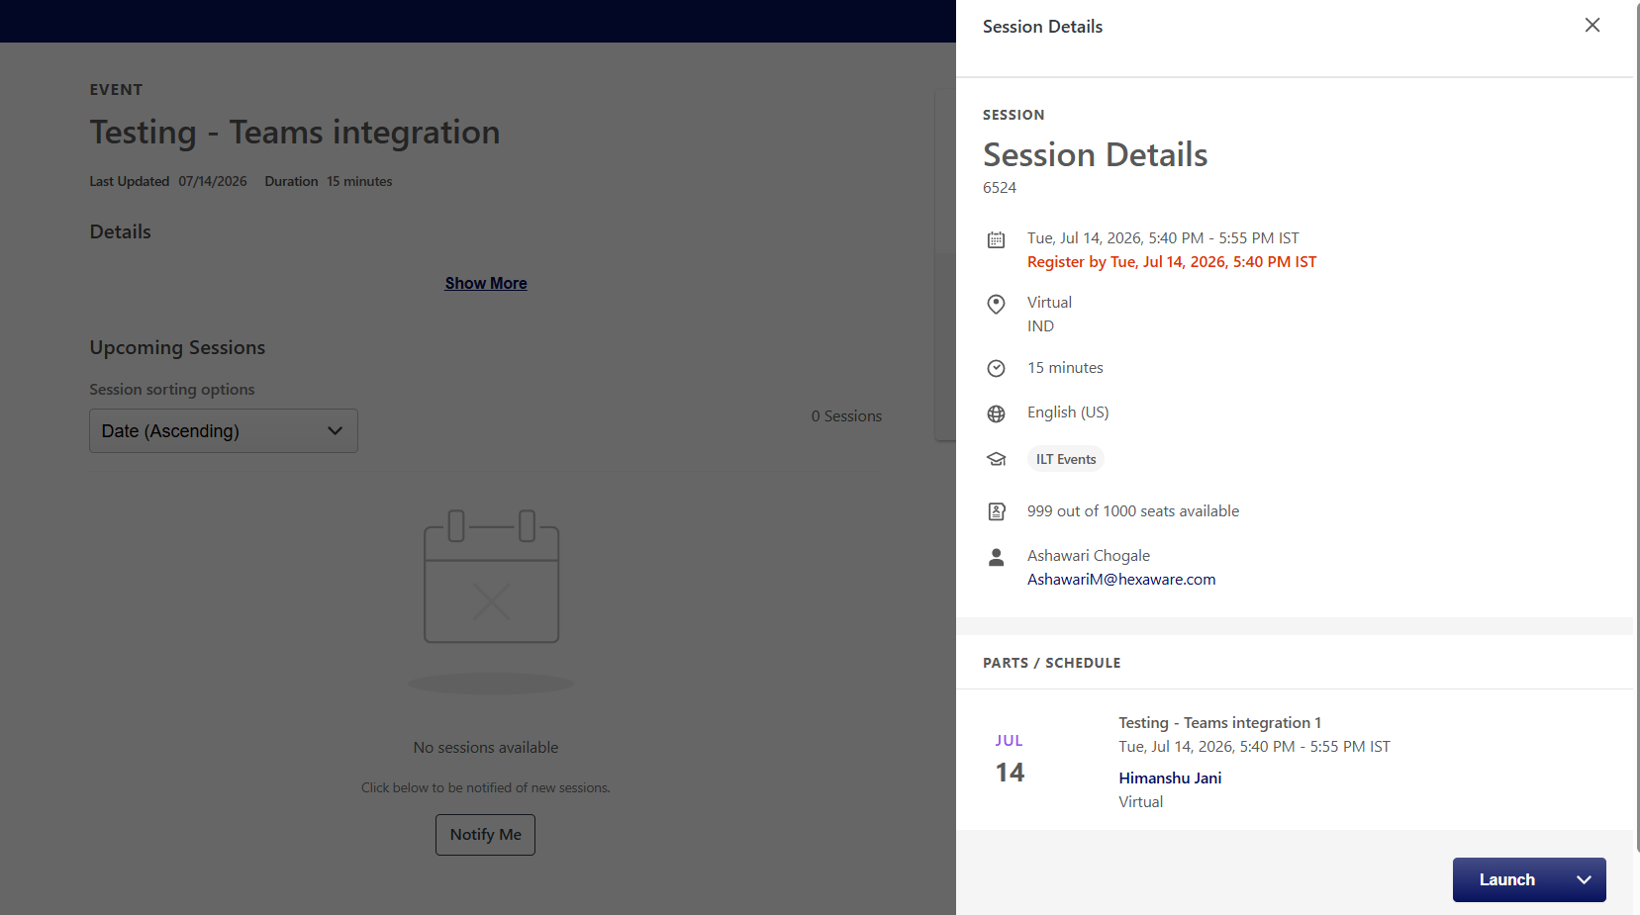

- Click on the launch button at the bottom of the page; this shall let the user join the training.
OR
- Open Events calendar on Hexaguru+ homepage.

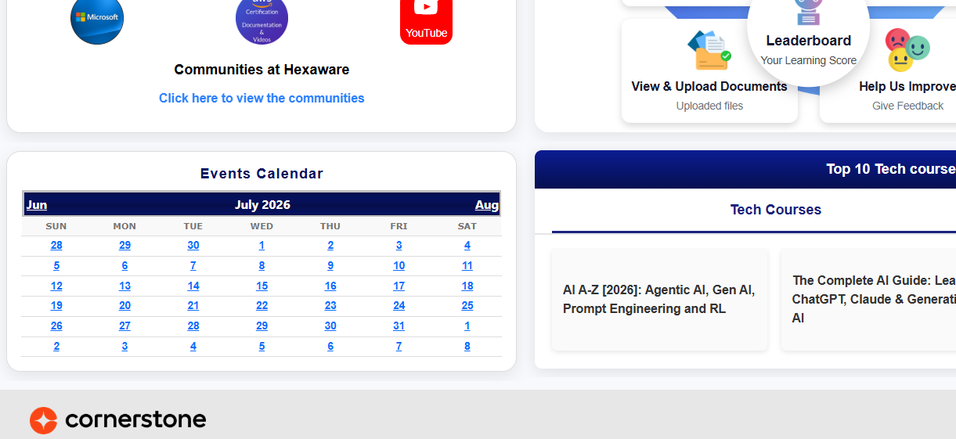

- Click on the date and select the training that is intended to join



- Click on the time of that training, it will open the training details page and user needs to launch the training while joining the same.

